Chapter 18, Problem 47.

Find the voltage v_{o}(t) in the circuit of Fig. 18.49. Let 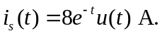
2 Ω

+

i_{s} 1Ω 1/2F v_{o}

–

Figure 18.49
For Prob. 18.47.

